**FINAL YEAR PROJECT RELATED DOCUMENTATION**

Base Paper - **A Specialized Evolutionary Approach to the bi-objective Travelling Thief Problem**

Dataset Used - eil51_n50_bounded-strongly-corr_01.ttp

Dataset Collected From - <https://cs.adelaide.edu.au/~optlog/CEC2014COMP_InstancesNew/>

Dataset Collected From Paper - <https://www.researchgate.net/publication/261361597_A_Comprehensive_Benchmark_Set_and_Heuristics_for_the_Travelling_Thief_Problem>

Command Line -

python3 main.py --files DATASET/your_dataset_file.txt --population 200 --mutation 0.05 --generations 2000

* **--population**: Set to **200**, which is a common choice that balances exploration and computational efficiency.
* **--mutation**: Set to **0.05** (or 5%), allowing for sufficient genetic diversity without destabilizing convergence.
* **--generations** Set to **1000** generations should be sufficient, however the limit has been set to 2000 to make sure the results converge.

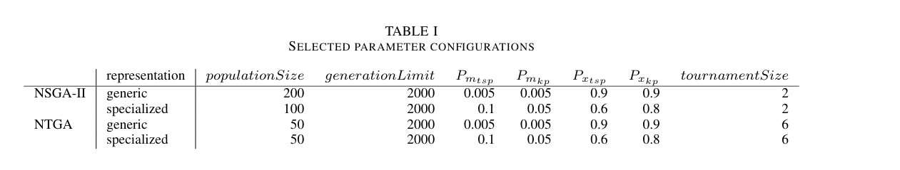

From The Base Research Paper